**Bolded = done (by devin)**

Graphs/Plots we need:

*FRAs*

* **FRA of isolated high pass filter w/ cutoff frequency**
* **FRA of isolated low pass filter w/ cutoff frequency**
* **FRA of isolated band pass filter w/ cutoff frequencies and center frequency**

*Oscilloscope Readings*

* Supply voltage plots (channel 1 -> +5 V, channel 2 -> -5 V, proves that chips are powered correctly, and that inverting boost works)

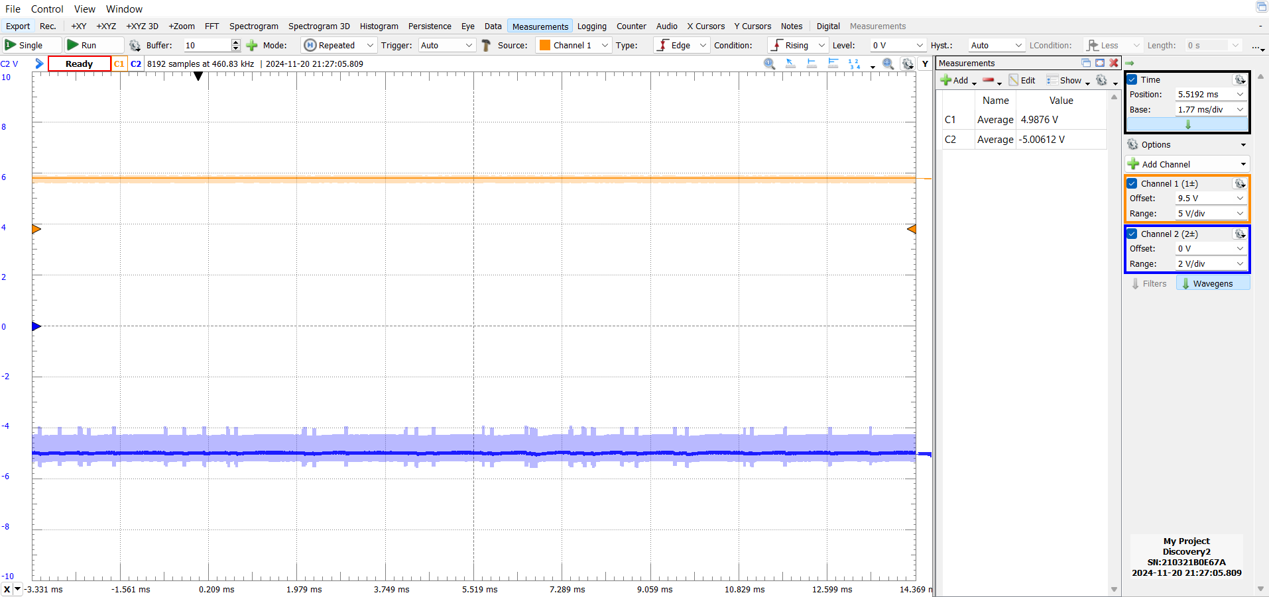

* Isolated ADC conversion plot (display of an analog input to stage and digital output, input can be any arbitrary wave, maybe 1 V amplitude, 1 Hz frequency like a heartbeat signal)

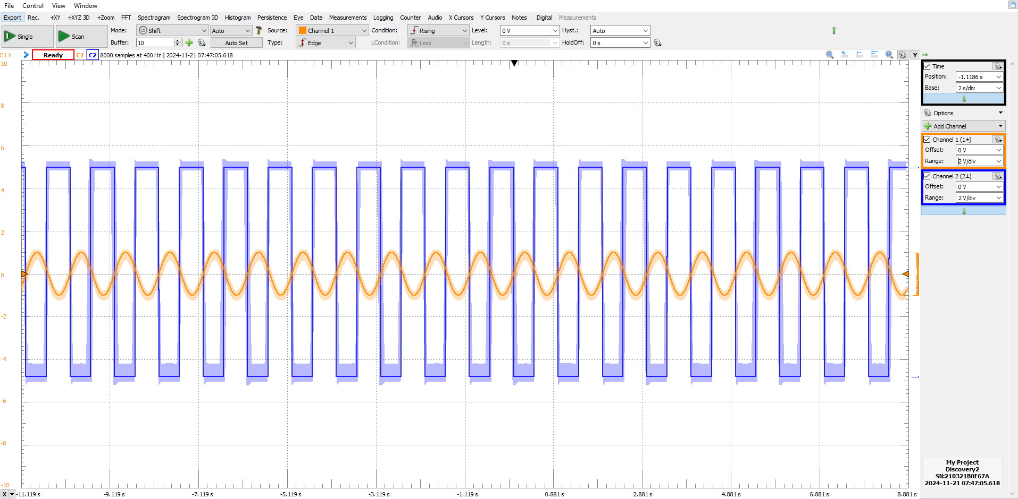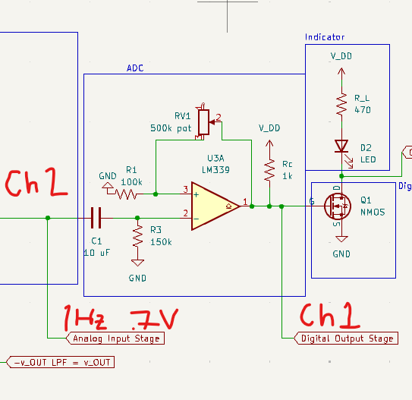

* Output of circuit with 2/3 Hz wave input instead of optical sensor (detach optical sensor and input 1 V amplitude, 0.67 Hz wave to high pass filter)

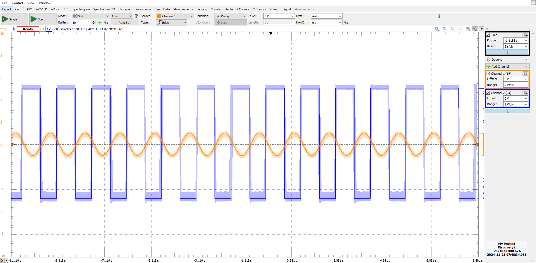

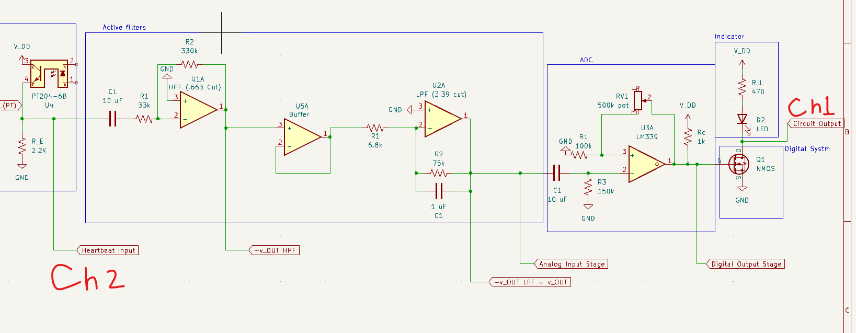

* Output of circuit with 10/3 Hz wave input instead of optical sensor (detach optical sensor and input 1 V amplitude, 3.33 Hz wave to high pass filter)

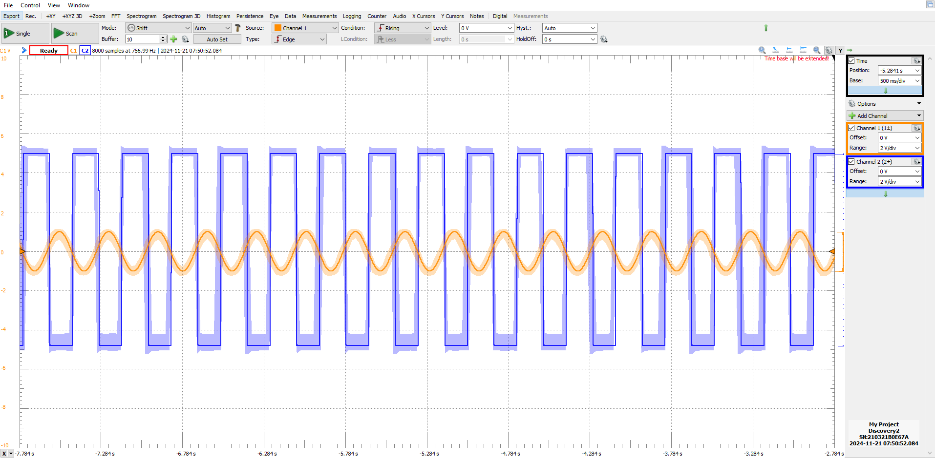



* Output of the fully integrated circuit with optical sensor input (reattach optical sensor and put finger in optical sensor, channel 1 -> output of optical sensor (heartbeat reading), channel 2 -> output of ADC stage (digital signal))

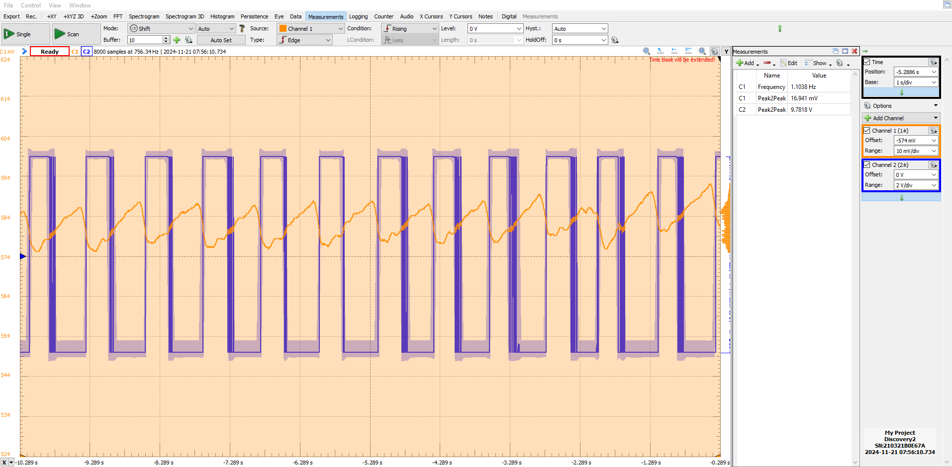

High pass filter with calculated values (in real_values kicad):

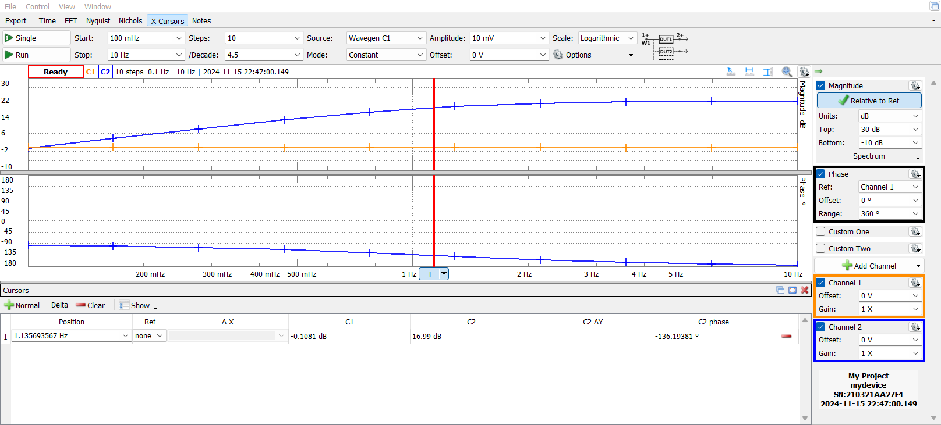(cutoff frequency: 1.136 Hz)

Low pass filter with calculated values (in real_values kicad):

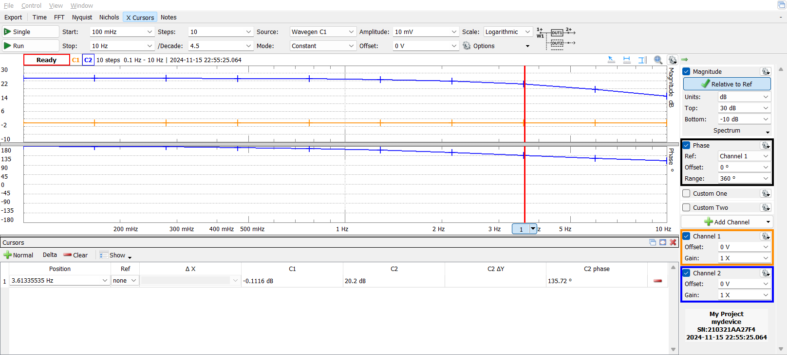(cutoff frequency: 3.613 Hz)

Band pass filter with calculated values (in real_values kicad):

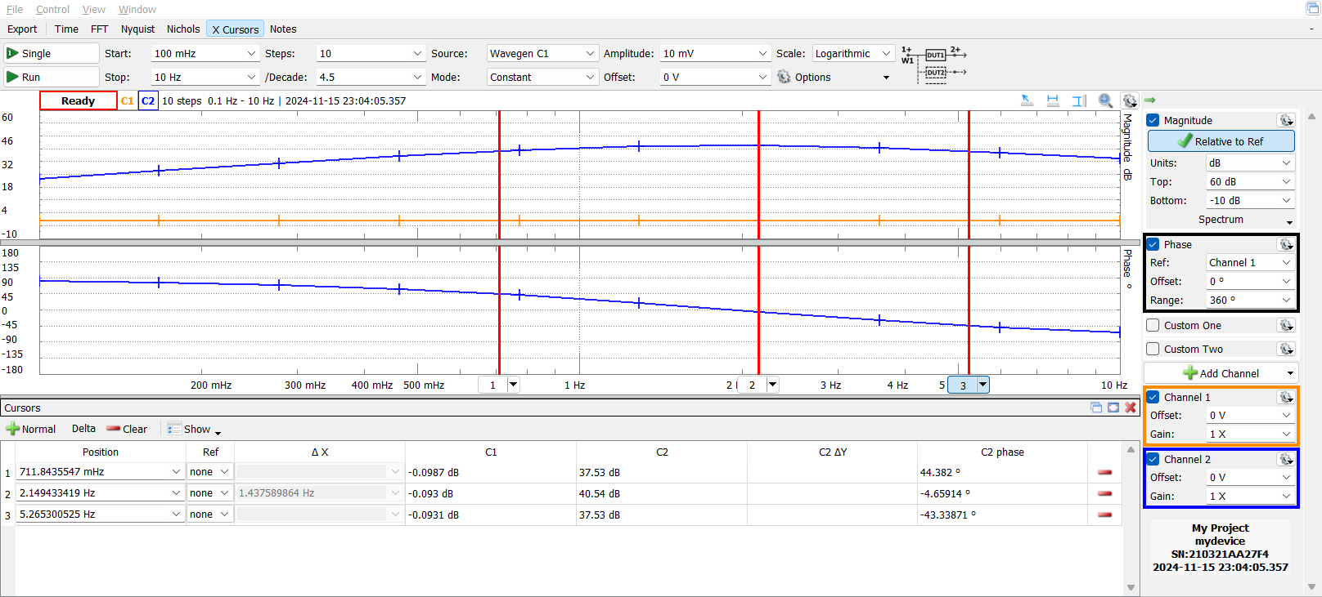(center frequency: 2.149 Hz, cutoff frequencies: 0.712 Hz, 5.265 Hz)

Band pass filter with updated values (in final_values kicad):

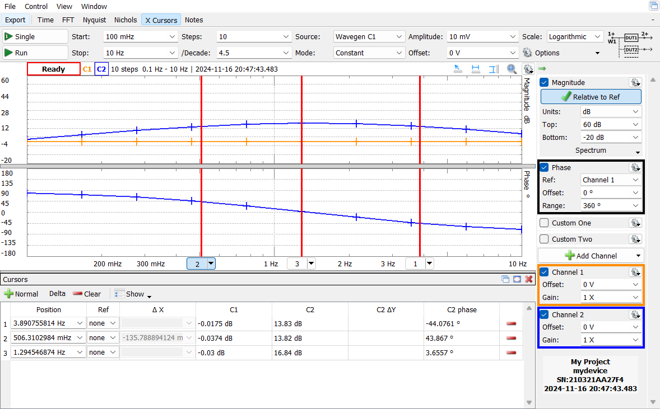(center frequency: 1.295 Hz, cutoff frequencies: 0.506 Hz, 3.891 Hz)

High pass filter with updated values (in final_values kicad):

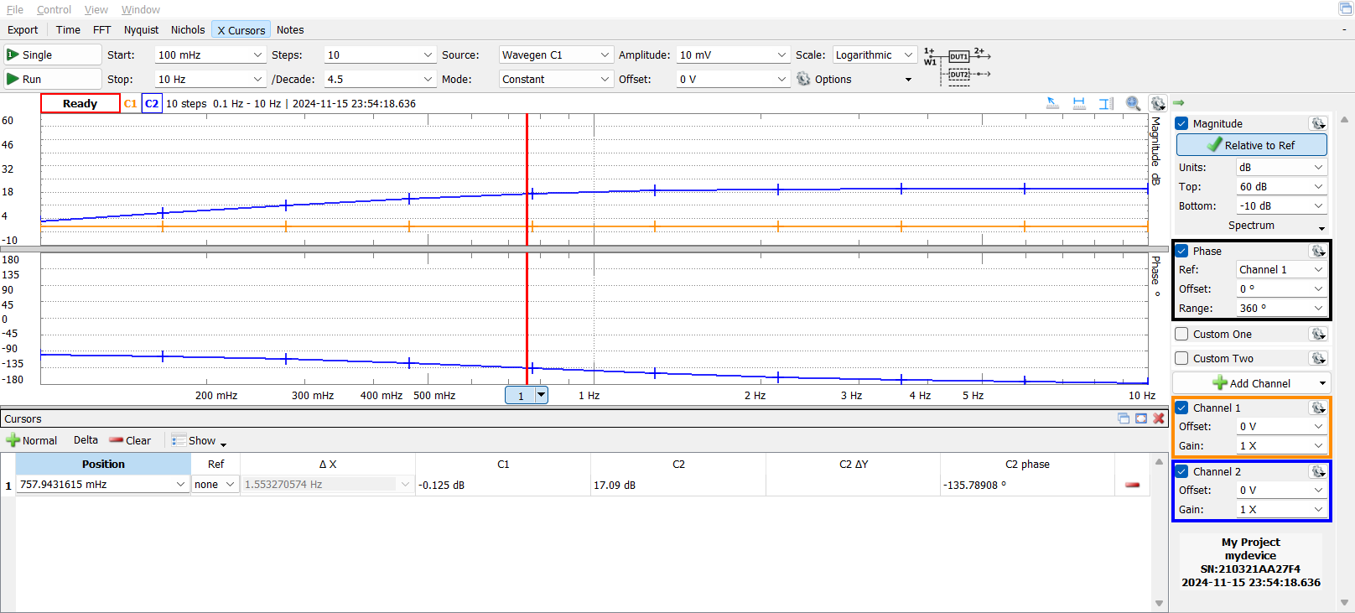(cutoff frequency: 0.758 Hz)

Low pass filter with updated values (in final_values kicad):

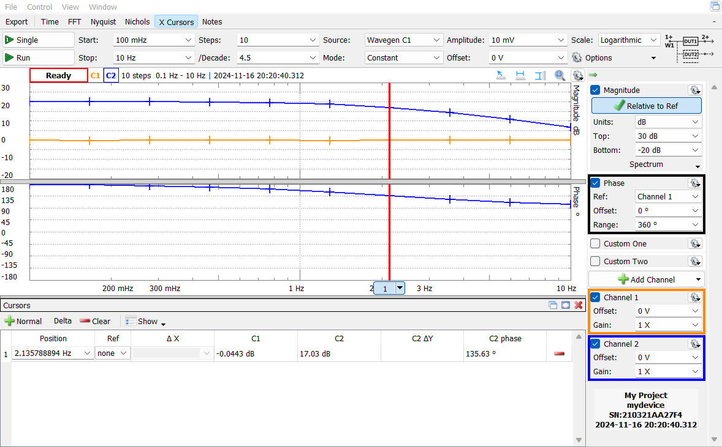(cutoff frequency: 2.136 Hz)

Optical sensor output:

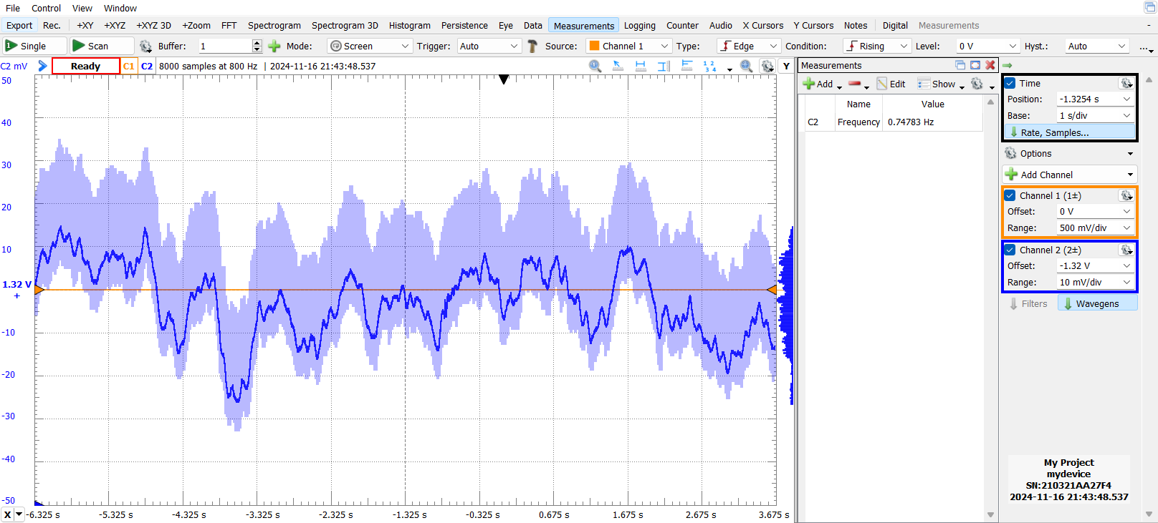

Thumb:

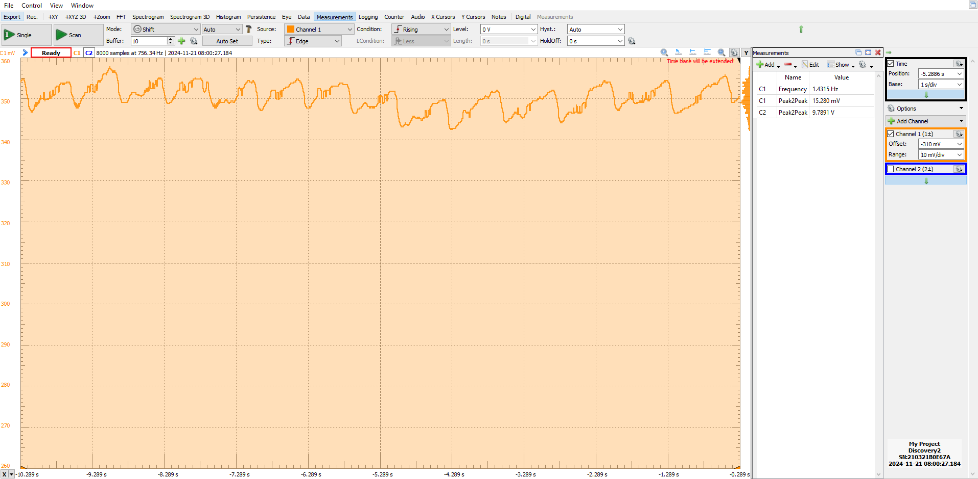

Pointer:

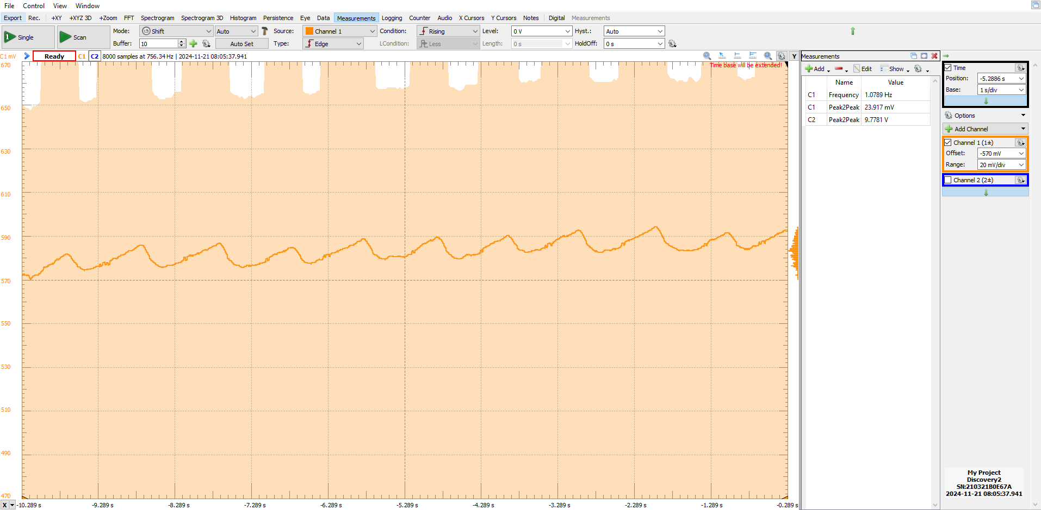

Active filter output:

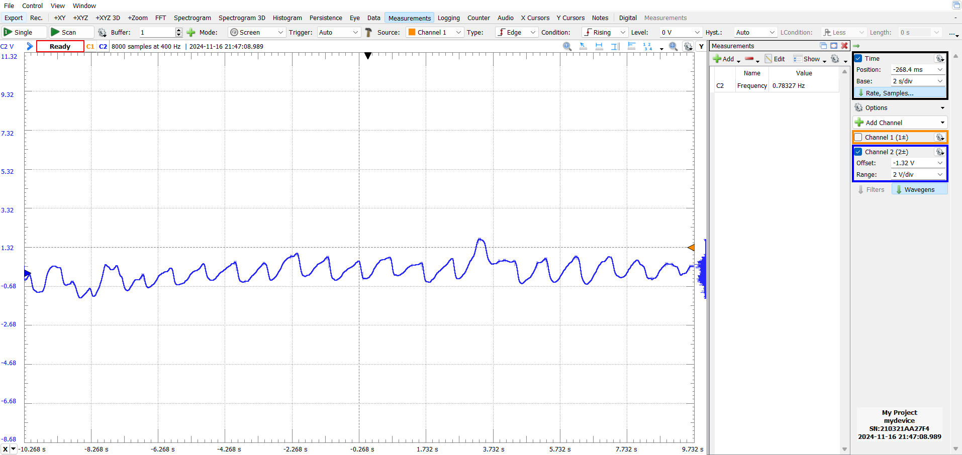

Thumb:

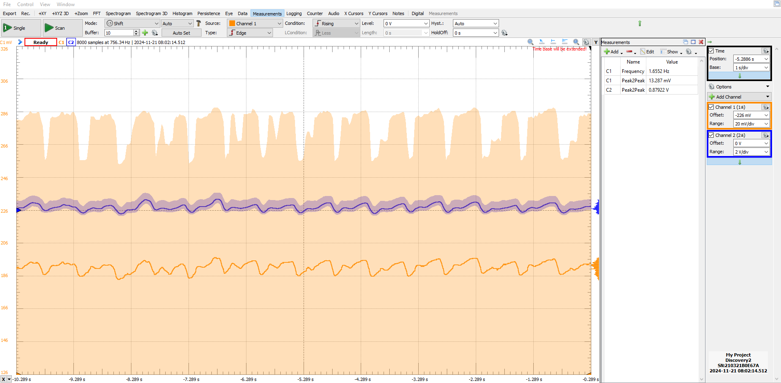

Pointer:

